IT8303   
AI & Human Interface

Lab 5: Introduction to Chatbot



**Exercise 1: First Taste of Multiple Chatbots**

In this exercise, we would like you to explore and use chatbots from 4 different companies. After that, we want you to have a discussion on the pros and cons of these chatbots, in the perspective of their intelligence, are they user friendly, and whether they can really resolve your queries.

1. Singtel Shirley: <https://www.singtel.com/contact-us>

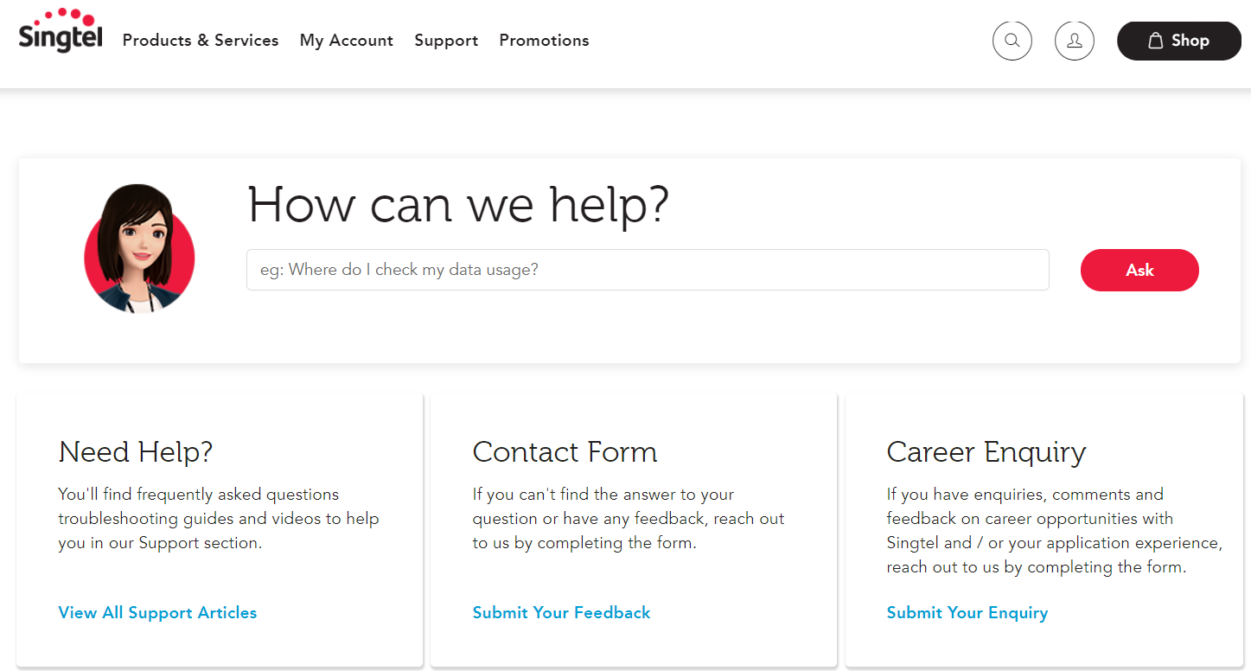

1. M1 Mindy: <https://www.m1.com.sg/support/contact-us>

1. Shopee: <https://help.shopee.sg/s/>

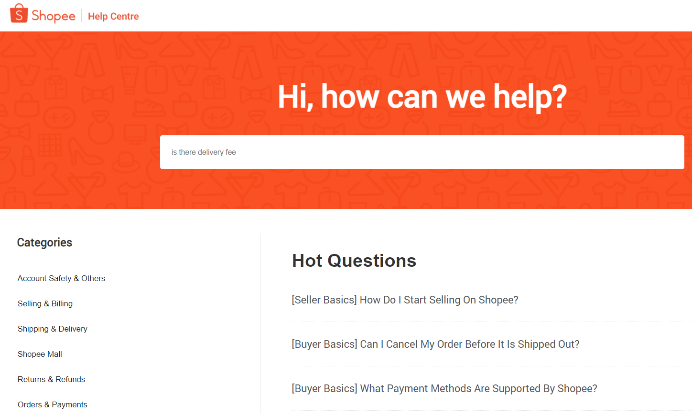

1. Lazada: <https://www.lazada.sg/contact/?spm=a2o42.home.footer_top.7.569a46b5xCgehD>

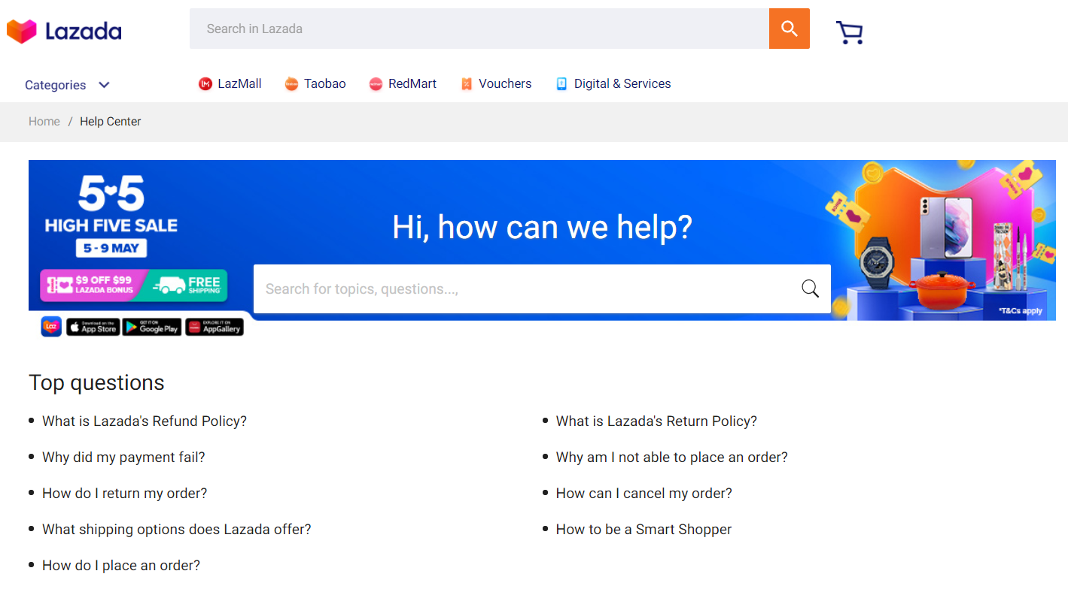

**Exercise 2: Chit Chat Bot**

If you think the chatbots from those commercial websites are not smart enough, maybe it is time to try a smarter chit chat bot from the below website:

* [www.cleverbot.com](http://www.cleverbot.com/)

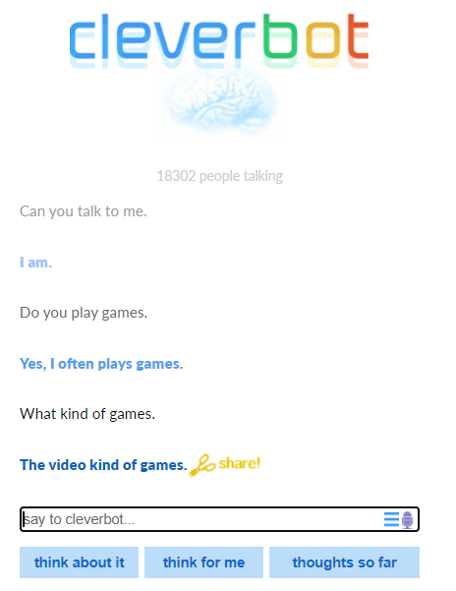

I want each of you ask the chatbot 10-15 questions, and count how many questions it can answer properly.